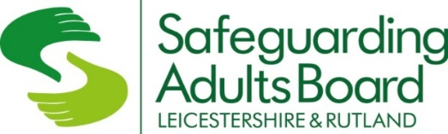
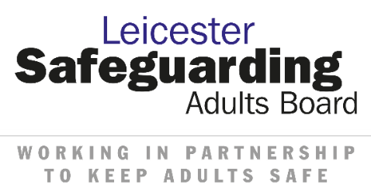

Leicester, Leicestershire & Rutland Safeguarding Adults Resources for
National Safeguarding Adults Week
21st – 27th November 2022

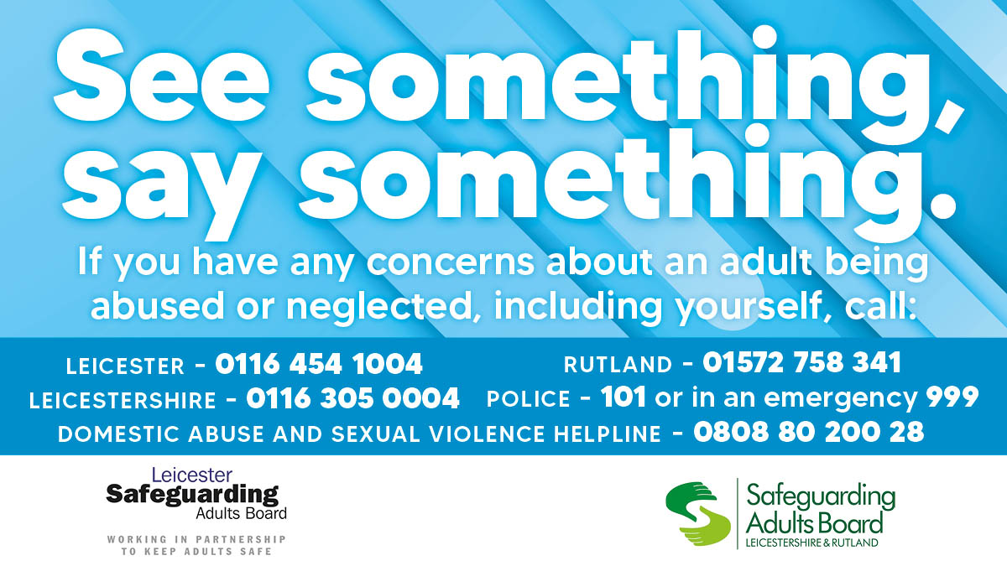

CONTENTS |  | Page Number
1 | Introduction | 3
2 | “See Something, Say Something” campaign | 4
3 | “Tricky Friends” animation | 5
4 | Recognising signs of abuse and neglect | 6-8
5 | “What is Adult Safeguarding?” information session | 9
6 | Activities for people who use your services | 10-14
7 | Adult safeguarding information in different languages | 15
8 | What can I do if I am being abused or I am worried that someone else is being abused or neglected? | 16-17
9 | Resources for Communication Teams | 18-23

- Introduction
It is National Safeguarding Adults Week 21st - 27th November 2022.
The Leicester, Leicestershire & Rutland Safeguarding Adults Boards have developed this resource pack for organisations to use with people who use your services and share with your communication teams within your organisation.
We hope you find this pack useful to engage with adults who use your services. If you would like any further information about safeguarding adults visit our websites or contact us.
Area | Web address | Email address
Leicester City | www.leicester.gov.uk/lsab | lsab@leicester.gov.uk
Leicestershire & Rutland | https://lrsb.org.uk/adults | lrspbo@leics.gov.uk

- “See Something, Say Something” campaign
This year the Boards would like to the focus on the importance of spotting signs of neglect and/or abuse. The “See Something Say Something” animation has been jointly developed by Leicester Safeguarding Adults Board and the Leicestershire and Rutland Safeguarding Adults Board.
The animation aims to raise awareness of the signs of abuse and neglect for people with care and support needs. The video shines a spotlight on domestic abuse, neglect and exploitation specifically cuckooing but these signs can also indicate other forms of harm.
When you know someone well and see changes in their behaviour, appearance, or they avoid or stop contact, then consider why this might be? Sometimes, adults with care and support needs may not be able to seek support, so the role of friends, family, carers and neighbours is very important in helping them to seek the help they require.
Here are the links for the animations, there are three animations.
- See Something Say Something: Domestic Abuse
- See Something Say Something: Neglect
- See Something Say Something: Exploitation, Cuckooing

Show these animations to the people who use your services, discuss the animations and signs of abuse and neglect.

- Tricky Friends Animation
"Tricky Friends" is a short animation developed by Norfolk Safeguarding Adults Board (NSAB) and adapted by Leicester, Leicestershire and Rutland with the permission of NSAB.

This video aims to help people with needs for care and support, and those who provide support to them, to understand what good friendships are, when they might be harmful, and what they can do. It is important that adults with care and support needs have positive opportunities to make and maintain friendships. We want them to be able to do this safely.

Please show/share this video Tricky Friends to people who use your services to understand good friendships, the video is 3 minutes long.

- Recognising signs of abuse and neglect
Sometimes signs of abuse and neglect are less obvious (hidden harm).
We would like organisations who support and provide services for adults to be aware of these signs and consider how they can raise awareness within their organisations and also how they can best have healthy discussions about signs of abuse or neglect with people who have care and support needs.
Opportunities for discussion with adults who use your service may be used during:-
- Planned activities
- Group discussions on health and wellbeing
- Whilst giving personal care

Opportunities for discussion with staff may be used during:-
- Team/Unit meetings
- Supervision
- Planned training

Additional resources for organisations to use
- wordsearch on pages 12-13
- watch the See Something Say Something animations together as a group. Links on page 4
- watch the Tricky Friends animations. Link on page 5
Focus on :-
- Signs that are visible to other people that the adult is being abused and/or neglect. Some examples :-
  - witnessing a person being shouted at,
  - not being clothed properly,
  - unexplained bruises on the body,
  - looking unkept,
  - adult looking withdrawn and not themselves,
  - looking like that they have lost weight or always hungry

- Signs that are not visible (hidden) to people that the adult is being abused and or neglect. For example:-
  - money or valuable possessions taken without the adult’s permission
  - other people taking control of someone’s money without them knowing
  - not being allowed to speak or express their own opinions
  - not being given medication on time
  - given wrong medication
  - being given food that is does not meet their dietary needs
  - not being allowed to talk to friends or family
  - not being taken to appointments
The above are just a few examples which could be useful to start the discussion.

What to do when someone discloses that they may be being abused/neglected?
If you work in an organisation, follow the procedures as set out in your organisation’s safeguarding adults policy.
If you are a friend or family member, contact your local adult social care services for more advice and support. Visit the Safeguarding Adults Boards’ websites for more information:-
- Safeguarding adults board (leicester.gov.uk)
- Leicestershire and Rutland Safeguarding Partnerships Business Office - Leicestershire and Rutland Safeguarding Adults Board (lrsb.org.uk)

What can adults do if they are being abused or are worried that someone else is being abused or neglected?
If you think you or someone you know is being abused or neglected tell someone you trust as soon as possible. If you need help to contact Adult Social Care, Police, or Health Services, ask a person you trust to help you.
If you, or the other person, is ill hurt or injured seek medical attention. If you, or the other person, is seriously ill, hurt or injured dial 999.
You can report the abuse or neglect of an adult with care and support needs to the Adult Social Care Services for the area they live:
- Leicester City - 0116 454 1004 (24 hours a day, 7 days a week)
- Leicestershire County Council - 0116 3050004
- Rutland County Council - 01572 758341
- if a crime has taken place you can report to Leicestershire Police
  - via their website www.leics.police.uk or
  - you can call 101
  - if it is an emergency, call 999

- “What is Adult Safeguarding?” Information Session
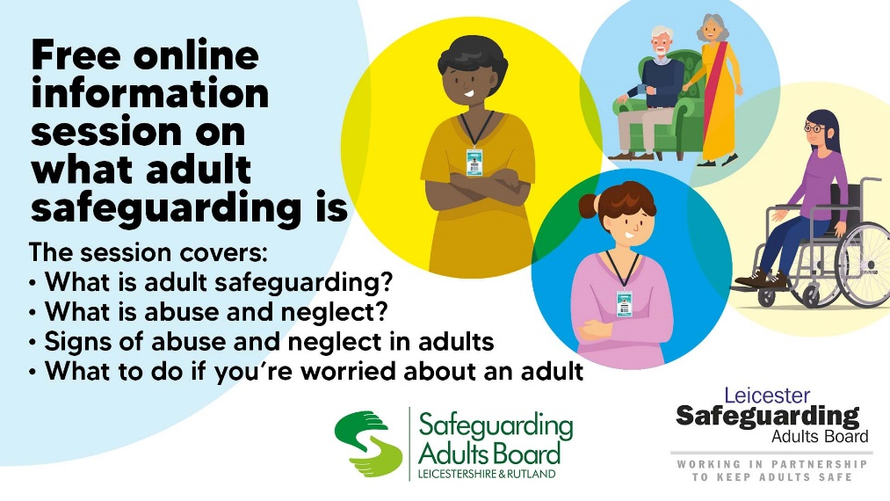

The Boards offer information sessions on “What is Adult Safeguarding?” to people who live in Leicester, Leicestershire and Rutland about adults who may be at risk of abuse or neglect.
During Safeguarding Adults Week an information session via MS Teams is taking place on Thursday 24th November at 10.00am, Click here to join the meeting alternatively email LSAB-events@leicester.gov.uk or telephone 0116 454 6270 to book a place.
The session is about 40 minutes long and covers
  - What is adult safeguarding?
  - What is abuse and neglect?
  - Signs of abuse and neglect
  - What to do if you have concerns

If you would like to arrange a separate information session for adults who use your services email LSAB-events@leicester.gov.uk or telephone 0116 454 6270.

Do not hesitate to contact us for more information.

- Activities for people who use your services
Pages 11-14 of this resource pack are activities for organisations to use with people who use their services about safeguarding adults.
These activities can be shared electronically or printed in publications for people who use your services. Please ensure you include the contents of page 16-17 in any publications if you choose to only use a couple of the activities.
In activity 1 there is an embedded document “What is Adult Safeguarding?” which is needed to complete this activity.
We hope you find these activities useful.

Feedback on activities
The Boards would be grateful if organisations can provide feedback on any of the activities used by organisations with people who use their services.
Please email LSAB-events@leicester.gov.uk with
- answers given during discussion about visible and not visible signs of abuse and/or neglect
- photos of any drawings produced
- other comments about any of the activities.

Thank you in advance for your support.

Activity 1 - What is Adult Safeguarding? – Easy Read
The sentences below are from the easy read version “What is Adult Safeguarding?” document. You can open the document by clicking on the picture below or this link https://www.leicester.gov.uk/media/tn2duudm/what-is-adult-safeguarding-easy-read-july-2021.pdf
Each sentence below has a missing word, match each word to complete the sentence using words from the list below. Each word can only be used once.
protecting trust harm anywhere
shopping tell hurts anyone

- Safeguarding means your right to live in safety, free from abuse and free from neglect.

- An adult at risk of is someone who may have needs for care and support and be experiencing, or at risk of, abuse or neglect and is unable to protect themselves.

- Care and support needs can be practical help with personal care, cooking, and cleaning.

- Abuse and neglect can happen in lots of different ways, for example when someone or treats another person badly.

- Abuse and neglect can happen .

- Adults with care and support needs could be abused and neglected
by .

- If you think you or someone you know is being abused or neglected
someone you trust as soon as possible.

- If you need help to contact Adult Social Care, Police or Health Services, ask a person you to help you.

Activity 2 - Safeguarding Wordsearch
Words to find

Upset Support Abuse Protect
Ignore Care Hurt Neglect
Tell Report Safeguard
Q | N | E | T | K | H | U | R | T | E
E | Y | J | R | S | Z | S | D | H | A
S | V | N | W | A | F | J | C | W | N
K | L | K | Y | F | E | R | G | T | E
A | B | U | S | E | H | E | Y | S | G
P | M | T | H | G | F | P | V | L | L
V | Q | N | R | U | W | O | N | U | E
H | F | K | E | A | E | R | S | B | C
L | K | S | P | R | O | T | E | C | T
I | J | E | T | D | T | E | W | A | Y
Y | R | Y | S | Q | Y | P | H | R | T
W | E | V | E | M | I | C | U | E | J
K | U | B | O | W | G | X | L | G | T
Z | P | G | U | U | N | B | V | N | H
D | S | U | P | P | O | R | T | E | S
I | E | W | L | J | R | Y | U | R | W
N | T | F | Y | T | E | L | L | D | O

Activity 3 - Some signs of abuse and neglect wordsearch
Words to find

Confused Bruised Hungry Withdrawn Untidy Tearful Unwell Lonely Scared
B | Z | C | O | N | F | U | S | E | D
S | U | P | U | C | J | I | O | V | Z
K | N | K | A | G | R | B | Q | H | U
F | W | I | T | H | D | S | A | W | N
I | E | S | E | N | W | O | P | F | T
R | L | G | A | S | A | M | Q | S | I
G | L | N | R | Q | T | E | C | J | D
M | V | Y | F | W | L | B | H | A | Y
S | Q | H | U | N | G | R | Y | M | F
B | Y | J | L | H | J | S | O | K | V
R | L | A | T | K | X | C | S | B | U
U | D | N | W | P | F | Z | V | G | Q
I | C | T | S | C | A | R | E | D | T
S | J | Z | F | T | W | B | J | K | O
E | L | O | N | E | L | y | H | T | A
D | N | A | K | A | S | X | W | L | S

Activity 4 - Create a Picture
Ask adults who use your services to create a picture about any of the following
  - Visible and/or hidden signs of abuse and neglect
  - See Something Say Something
  - Safeguarding adults
They can use computer packages, collages, paper and other medium they prefer.

- Adult Safeguarding information in different languages
The table provides resources produced in different languages by the Leicester Safeguarding Adults Board, which may be of benefit to organisation with people who use their services. These are also available from our website www.leicester.gov.uk/lsab

What is Adult Safeguarding – Easy Read

Safeguarding Adults in English

Safeguarding Adults in Bengali

Safeguarding Adults in Gujarati

Safeguarding Adults in Hindi

Safeguarding Adults in Punjabi

Safeguarding Adults in Urdu

- What can I do if I am being abused or I am worried that someone else is being abused or neglected?

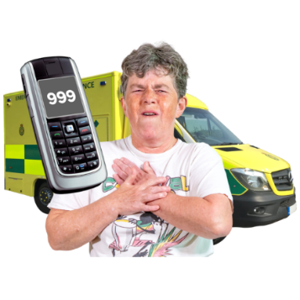  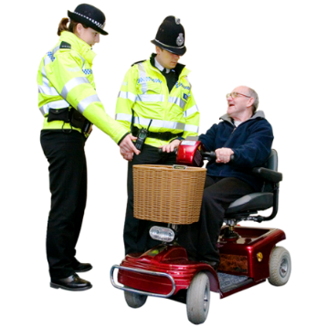 | If you think you or someone you know is being abused or neglected tell someone you trust as soon as possible.  If you need help to contact Adult Social Care, Police or Health Services, ask a person you trust to help you.  If you, or the other person, is ill hurt or injured seek medical attention.  If you, or the other person, is seriously ill, hurt or injured dial 999.  You can report the abuse or neglect of an adult with care and support needs to the Adult Social Care Services for the area they live:  - Leicester City  0116 454 1004 (24 hours a day, 7 days a week)  - Leicestershire County Council  0116 3050004  - Rutland County Council  01572 758341  - if a crime has taken place you can report to Leicestershire Police  - via their website www.leics.police.uk or  - you can call 101  - if it is an emergency, call 999  Organisations will work together with you to prevent the abuse and neglect taking place.
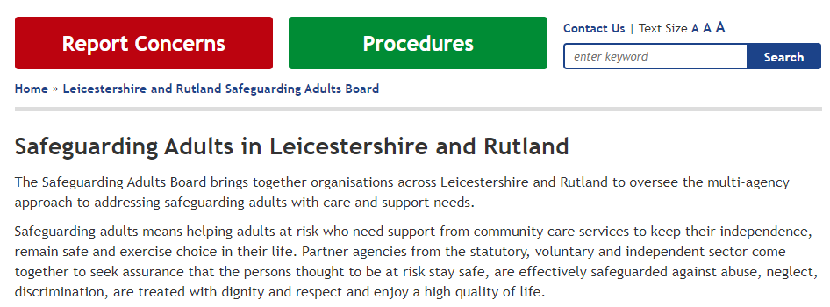 | How can I find out more information about safeguarding adults?  Leicester Safeguarding Adults Board  Take a look at the Leicester Safeguarding Adults Board website www.leicester.gov.uk/lsab  If you go to a community group in Leicester and would like more information about safeguarding adults, please contact Leicester Safeguarding Adults Board, at LSAB@leicester.gov.uk or on 0116 454 6270 to arrange a virtual session (please do not report abuse or neglect via this route).  Leicestershire and Rutland Safeguarding Adults Board  Take a look at the Leicestershire and Rutland Safeguarding Adults Board website https://lrsb.org.uk/adults  or email lrspbo@leics.gov.uk

- Resources for Communication Team

If your organisation is active on social media, share the links and the proposed messages shown on the following pages to help raise awareness on the spotting the signs of abuse and neglect.

Please note
- it is Safeguarding Adults Week from 21st -27th November use hashtag #SafeguardingAdultsWeek

- it has been agreed that the See Something Say Something campaign will start on 21st November to 2nd December, use hashtag #SeeSomethingSaySomethingLLR

When posting messages during Safeguarding Adult Week use both hashtags if possible.

In addition, type a description of the asset in Alt Text on twitter to make the post more accessible to people with visual impairments.

Asset - Core message asset

Proposed messages
- This week is #SafeguardingAdultsWeek. If you notice changes in an adult with care and support needs which cause you concern, contact adult social care services in the area they live.
#SafeguardingAdultsWeek #SeeSomethingSaySomethingLLR

- If you are concerned that an adult with care and support needs may be experiencing abuse and/or neglect, contact adult social care services. #SafeguardingAdultsWeek #SeeSomethingSaySomethingLLR

- If you are an adult with care and support needs who is experiencing abuse and/or neglect you can contact adult social care for support #SafeguardingAdultsWeek #SeeSomethingSaySomethingLLR

See Something Say Something Asset
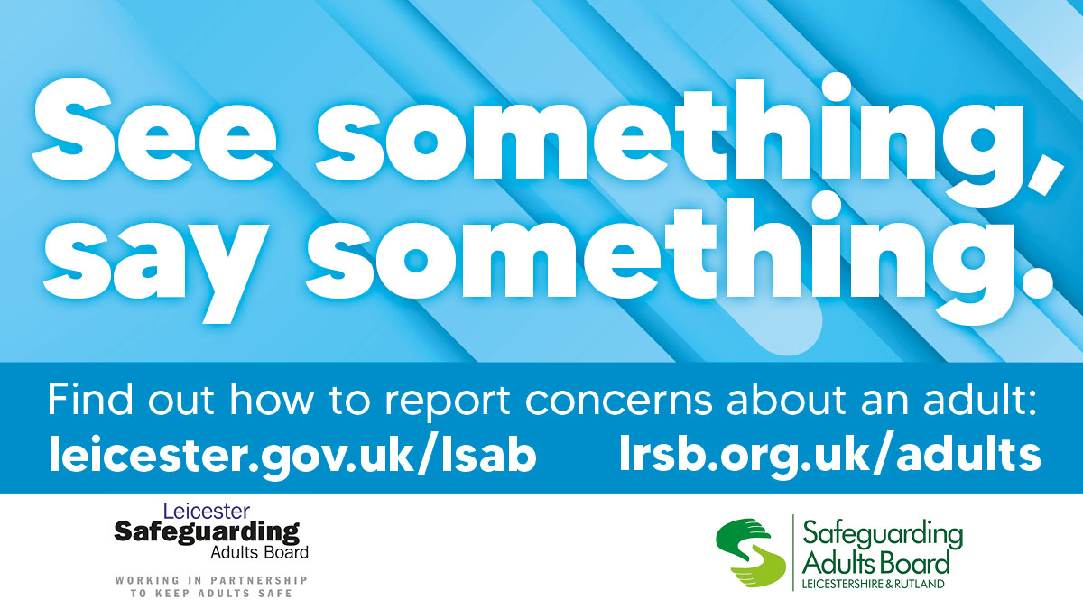

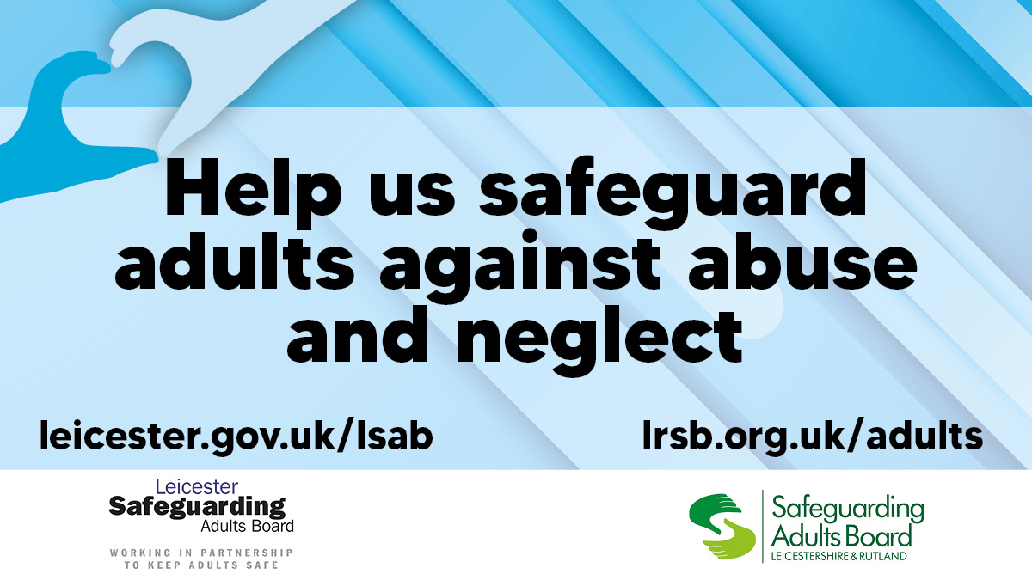
Proposed messages
- Have you seen the domestic abuse video produced by Leicester, Leicestershire & Rutland’s Safeguarding Adults Boards? https://youtu.be/TYOfIwmutzo, #SeeSomethingSaySomethingLLR #SafeguardingAdultsWeek

- Could you spot the signs of neglect in an adult at risk? Watch Leicester, Leicestershire and Rutland’s Safeguarding Adults Boards’ video to find out https://youtu.be/amFgdMwSeaM #SeeSomethingSaySomethingLLR #SafeguardingAdultsWeek

- Could you spot the signs of domestic abuse in an adult at risk? Watch Leicester, Leicestershire and Rutland’s Safeguarding Adults Boards’ video to find out https://youtu.be/TYOfIwmutzo #SeeSomethingSaySomethingLLR #SafeguardingAdultsWeek

- What are the signs of adult exploitation? Watch Leicester, Leicestershire and Rutland’s Safeguarding Adults Boards’ video to find out https://youtu.be/o7qeGNidpTY #SeeSomethingSaySomethingLLR #SafeguardingAdultsWeek

- Have you seen the video on exploitation/cuckooing produced by Leicester, Leicestershire & Rutland’s Safeguarding Adults Boards? https://youtu.be/o7qeGNidpTY, #SeeSomethingSaySomethingLLR #SafeguardingAdultsWeek

- Have you seen the video on neglect produced by Leicester, Leicestershire & Rutland’s Safeguarding Adults Boards? https://youtu.be/amFgdMwSeaM #SeeSomethingSaySomethingLLR #SafeguardingAdultsWeek

See Something Say Something Campaign Statistics
The Safeguarding Adults Boards would be grateful if organisations can provide statistics on their posts on social media during the campaign week. Please complete the table below and returned to LSAB-events@leicester.gov.uk by 16th December 2022.

Date | Name of Organisation | Social Media platform | Impressions | Engagements | Clicks to video | Number of views

Promote the “What is Adult Safeguarding?” Information Session
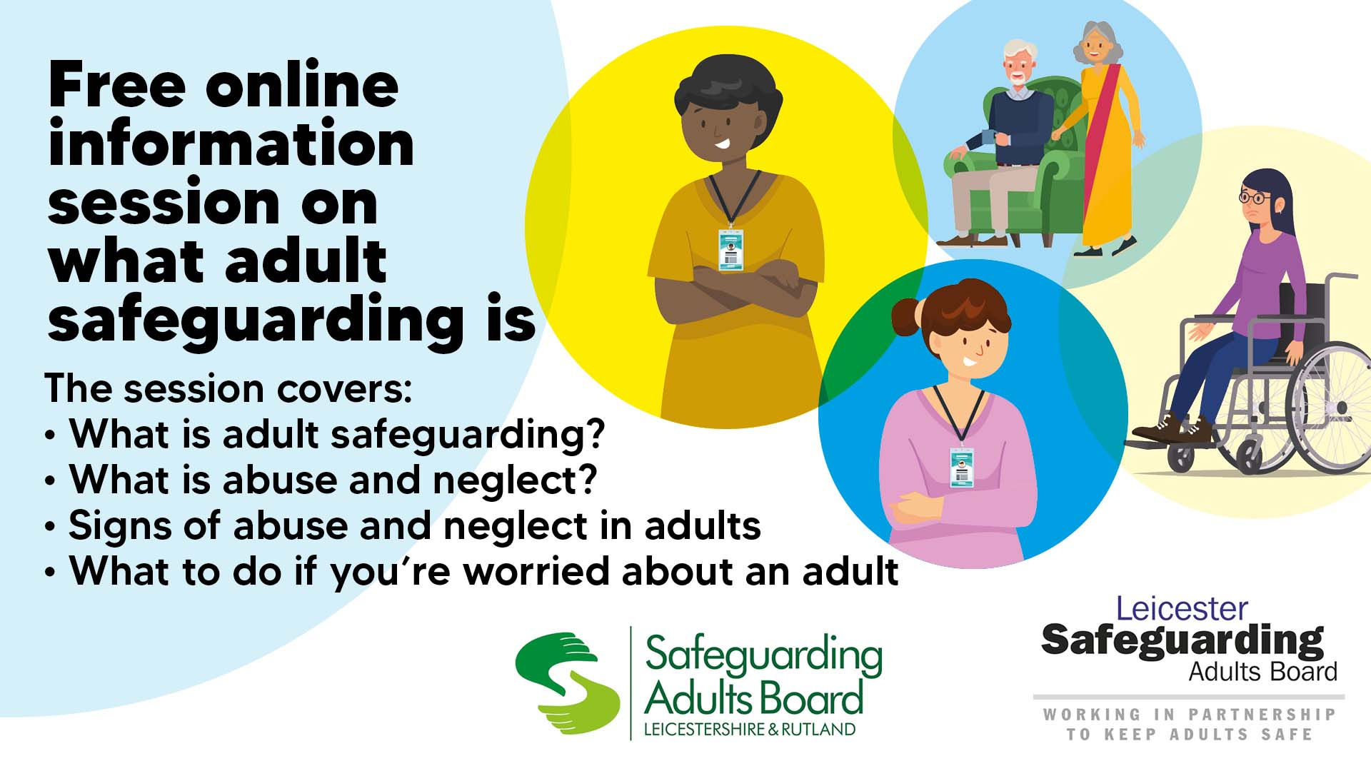

Suggested message

- Free online information session for people who live in Leicester, Leicestershire & Rutland on “What is Adult Safeguarding?”, on Thursday 24th November at 10.00am.

To book a place email lsab-events@leicester.gov.uk or call 0116 454 6270. #WhatisAdultSafeguarding

