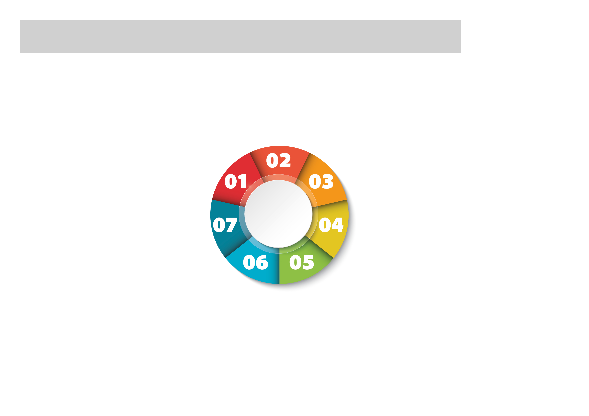

Type here

Type here

Type here

Type here

Type here

Type here

Type here

Type here

**03**

**02**

**07**

**04**

**05**

**06**

**01**

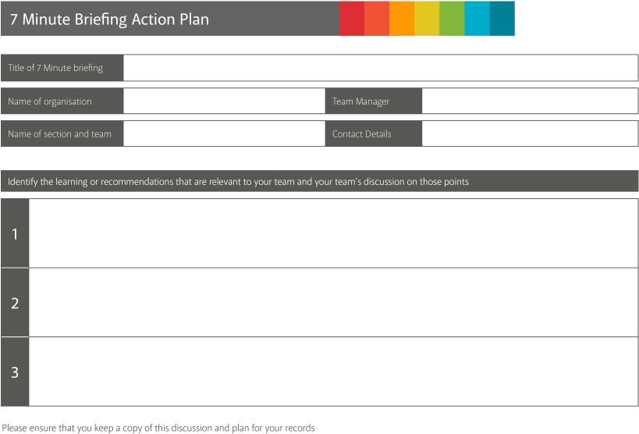

Type here

Type here

Type here

Type here

Type here

Type here

Type here

Type here

Type here

Type here

Type here

Type here

Type here

Type here

Type here

